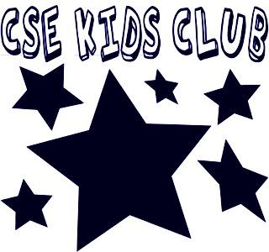 CSE Kids Club Program Policies
1. Admission
Each student must be enrolled in the after- school program by a parent or legal guardian. The fee for the CSE Kids Club is $25 or $35 per activity. A parent/guardian must enroll the student using the registration/emergency form on our website www.csepta.my-pta.org . Completed form and payment must then be sent to the office in an envelope labeled “CSE Kids Club” or payment submitted online. The fee and paperwork must be sent in order for a student to be enrolled. The program is first come, first serve. Once the class is full, no new registrations will be accepted. You will be notified and payment returned if the session is full.

2. Attendance
Daily attendance will be taken during the classes and activities. All students are to attend all classes regularly and promptly for which they are scheduled. If a student is going to be absent from the after school program, the parent/guardian is asked to call the school office with that information.

3. Discipline
The purpose of a discipline policy is to facilitate a positive after-school climate where each student feels safe and secure; where staff agree on general principles of discipline; where parents are kept informed of their child’s behavior and are encouraged to support the staff’s decision and where all students are provided with opportunities to grow in personal and social development. Rules and regulations outlined by the instructors will be applied to the CSE Kids Club Program and all students are expected to obey them. If a student fails to do so for the first time, the parent will be informed and the student will get a warning. If the Program Coordinator receives another discipline referral from the same student, the parent will be contacted and the student will be suspended from the after school program for one week. If a third discipline incident happens, the child will be suspended for the remainder of the existing session of the after school program and the session that follows. A child with frequent discipline issues will not be allowed to enroll for the existing academic year.

4. Pick Up Policy
The CSE Kids Club program will run from 3pm-4pm. Parents are asked to promptly pick up their child at 4 pm at the rear entrance of the school off of Knapp Road. Parents may park their car and enter through the side door entrance by the cafeteria to pick up their child. Please keep in mind, parents will be running this program so your promptness is greatly appreciated. After 2 late pick up violations, we will ask that your child not attend the next CSE Kids Club session offered.

5. Medication Policy
A parent or guardian will be called to pick up a child who is sick or injured. Medicine will not be administered without written permission from the parent/guardian.

